Mimecast Add-in Missing in Microsoft Outlook

Introduction
This article describes how to troubleshoot and resolve issues where the Mimecast add-in is missing or not visible in Microsoft Outlook or Microsoft Word.
Mimecast for Outlook is an add-in that integrates email security, archiving, and awareness features directly into Microsoft Office applications. If the add-in is not available, users may be unable to access Mimecast functionality such as reporting emails, managing holds, or accessing secure messaging.
Typical users affected: All users with Mimecast installed via Software Center.

Process
Follow the steps below to troubleshoot and fix the issue:

1. Check if Mimecast is Visible in UI (Quick Validation):
In Outlook / Word Ribbon:
- Open Outlook or Word
- Look at the top ribbon (toolbar)
- Check if a Mimecast tab or buttons are visible
If visible → Add-in is installed and loaded
If missing → Continue troubleshooting

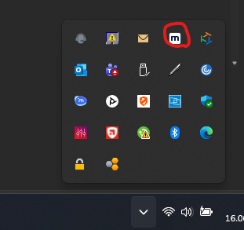
In System Tray (Taskbar Icons):
- Click the upward arrow (^) in the bottom-right taskbar (as shown in screenshot)
- Look for the Mimecast icon (as shown in screenshot)
If Mimecast icon is present → Add-in may be installed but not loaded in Office
If icon is missing → Mimecast is likely not installed or not running
Conclusion:
- Missing in both ribbon and system tray = strong indication Mimecast installation issue
- Present in tray but not ribbon = likely add-in disabled or not loaded

2. Verify Add-in Status in Outlook:
- Go to:
  - File → Options → Add-ins
- Check:
  - Active Application Add-ins
  - Disabled Application Add-ins
    - If Mimecast appears here:
      - Click Manage → Disabled Items → Go
      - Re-enable it

3. Apply Known Fix (Support Article):
- Follow:
  - https://adsupport.happyfox.com/kb/article/42-mimecast-missing-on-outlook/
Key checks:
- Outlook not in safe mode
- Add-in not disabled due to performance
- Restart Outlook after applying changes

5. Reinstall Mimecast Add-in:
Uninstall:
- Control Panel → Programs → Programs and Features
- Uninstall Mimecast for Outlook
Reinstall:
- Login in to the affected device as an administrator
- Open Software Center and install Mimecast
- Restart the machine
- Log back in as the user
- Mimecast should now function normally

Affected Technology
- Microsoft Outlook (Desktop)
- Mimecast for Outlook Add-in (COM Add-in)
- Software Center (SCCM deployment environment)
- Microsoft Office / Microsoft 365 Apps

Sources
- Mimecast FAQ (Official):
  - https://mimecastsupport.zendesk.com/hc/en-us/articles/34000462554003-Mimecast-for-Outlook-Frequently-Asked-Questions#h_01JAD20GE29HWCAGEST7AVS3J6
- TechHit – Fix Missing Outlook Add-in:
  - https://www.techhit.com/how-to/fix-missing-add-in-outlook-2016-2013-2010/
- AD Support – Mimecast Missing in Outlook:
  - https://adsupport.happyfox.com/kb/article/42-mimecast-missing-on-outlook/

